EX NO:1
STARBUCKS SALES AND MARKETING ANALYSIS

AIM:
Problem Statement: Coffee Chain Sales and Marketing analysis, you are a Data Analyst working for Starbucks. The company is trying to assess marketing strategy effectiveness and sales distribution across various products they sell. You have been supplied with three data sets one for location, products and sales details in different format, and management has asked to show the following:

- Sales trend across two product categories, tea and coffee.
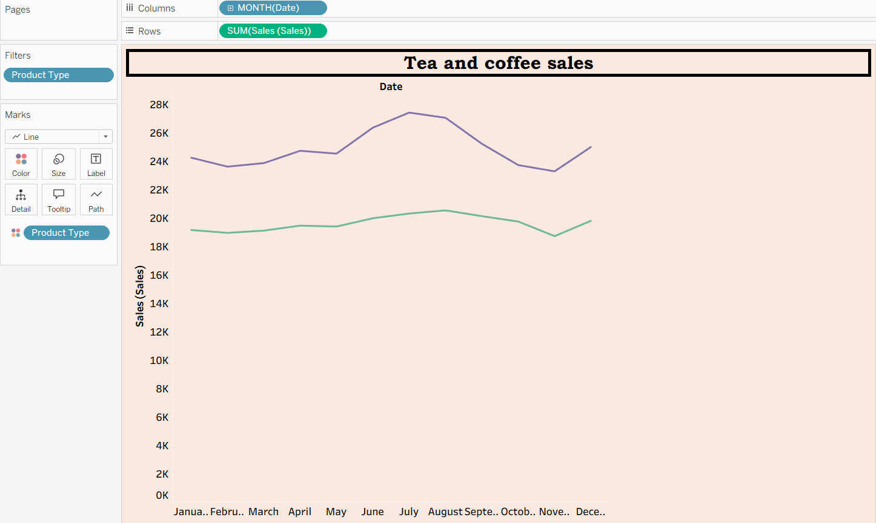

- Using Pie chart, show total sales distribution across product categories.
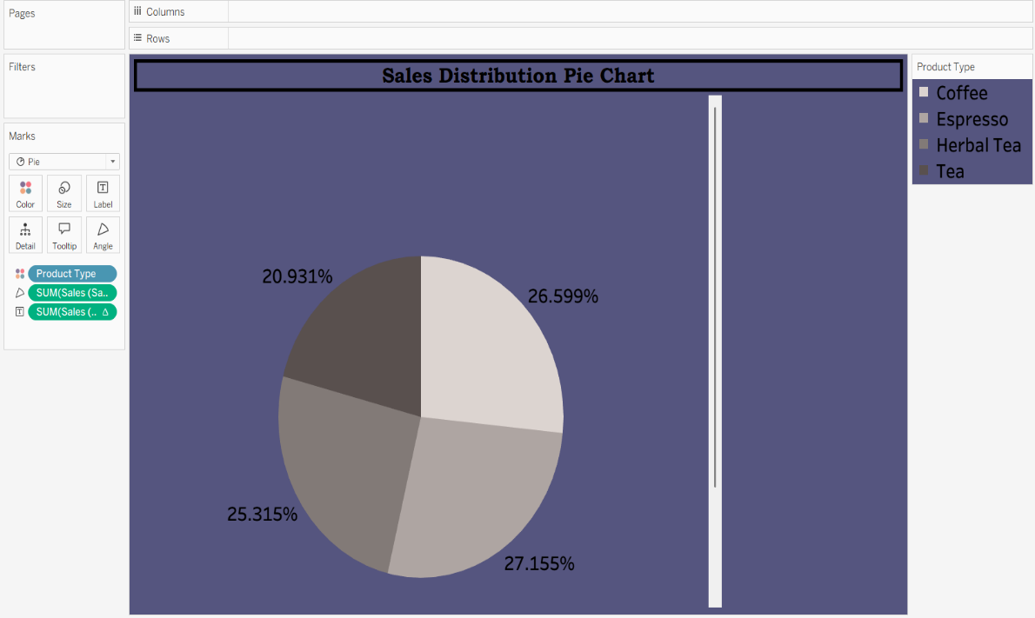
- Is there any correlation between Sales and Marketing Expenses? Any changes within the years? Build a scatter plot.



